Deep Learning
Deep learning is a subset of machine learning that uses neural networks with many layers (“deep” networks) to learn patterns directly from large amounts of data.
DL
ML
AI

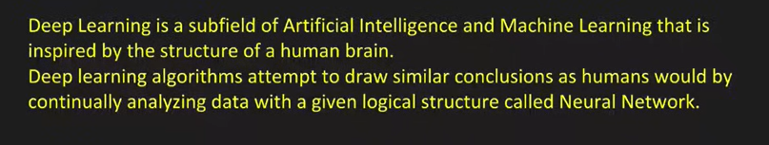

How it works
A deep learning model is made of multiple layers of artificial neurons:
- Input layer → receives raw data (pixels, words, numbers)
- Hidden layers → learn increasingly complex patterns
- Output layer → produces predictions or decisions
The model improves by adjusting its internal weights using a process called backpropagation.

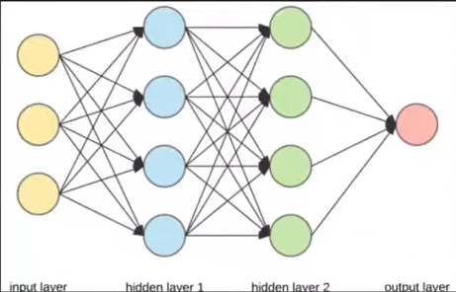

Why deep learning is important
Deep learning powers many modern AI systems, including:
- 🖼️ Image recognition (face unlock, medical imaging)
- 🗣️ Speech recognition (voice assistants)
- 📝 Natural language processing (chatbots, translation)
- 🚗 Autonomous driving
- 🤖 Generative AI (ChatGPT, image generation, video models)

Deep learning vs machine learning
Machine Learning | Deep Learning
Uses hand-crafted features | Learns features automatically
Works well with smaller data | Needs large datasets
Simpler models | Large neural networks
More interpretable | Less interpretable

Common deep learning models
- CNNs (Convolutional Neural Networks) – images & video
- RNNs / LSTMs – sequences & time-series
- Transformers – language models, GenAI
- Autoencoders – compression & anomaly detection

Initial layers detect primitive features like edges and the deep layers extracts more complex features.
ML is used sometimes because it takes less training time and less hardware cost

ANN stands for Artificial Neural Network.
Simple definition
An Artificial Neural Network (ANN) is a machine learning model inspired by the human brain, made up of interconnected artificial neurons that learn patterns from data to make predictions or decisions.

How ANN works (in simple terms)
- Input layer receives data (numbers, pixels, features)
- Hidden layers process the data using weights and activation functions
- Output layer produces the final result (prediction or classification)

Perceptron
A perceptron is the simplest type of artificial neural network and the basic building block of ANNs.

A perceptron is a single artificial neuron that takes multiple inputs, applies weights, adds a bias, and produces an output using an activation function.

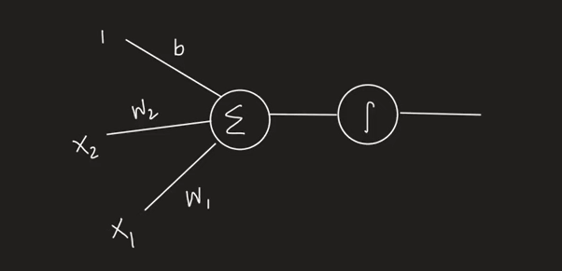
W1, w2 are weights and b is base
1, x1, x2 are inputs

🔹 How a perceptron works
- Multiply each input by a weight
- Add them together
- Add a bias
- Apply an activation function (usually a step function)
$$\text{output}=\left\{\begin{matrix}1 & \text{if }∑(w_{i}x_{i})+b≥0 \\ 0 & \text{otherwise}\end{matrix}\right.$$
z=x1w1 + x2w2 + b*1
This goes to activation function which puts the value of z to some range
Like [0,1] [-1,1]
Example if z >= 0 make the value as 1
If it is < 0 make the value as 0 (Step function)
Relu, tanh

How this works?
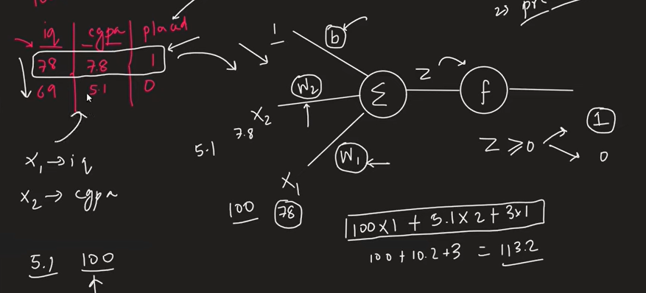

w1 = 1, w2=2, b=3

Key components
- Inputs (x₁, x₂, …) – feature values
- Weights (w₁, w₂, …) – importance of each input
- Bias (b) – shifts decision boundary
- Activation function – decides output (on/off)

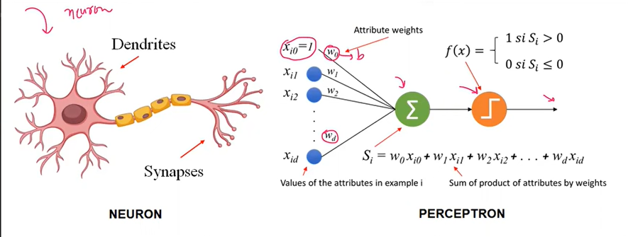

Ax + By + C >= 0 it’s the equation of line
In 3d it’s a plane and in 4d it’s a hyper plane
It separates 2 regions
And works with linear data or partially linear data (limitation)
Cannot work with non linear data
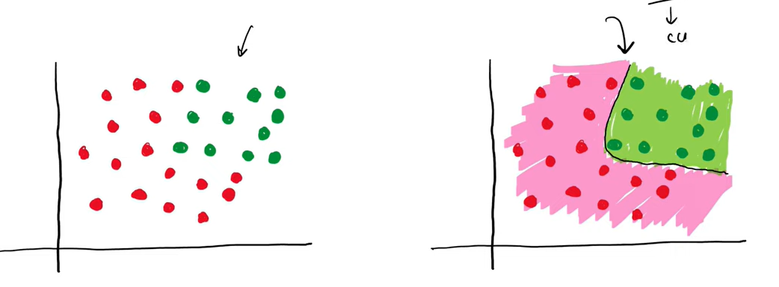
Multilayer Perceptron

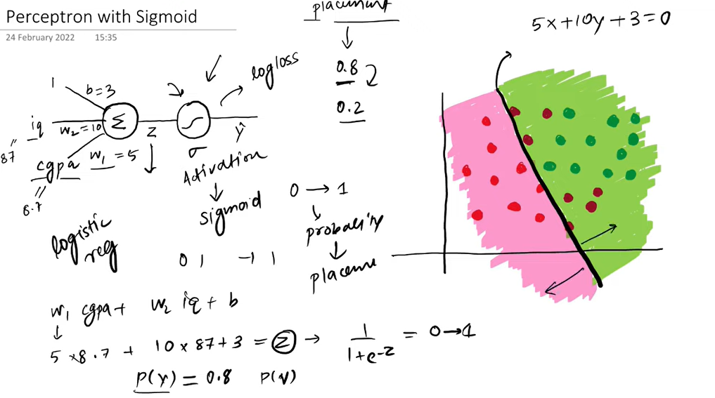

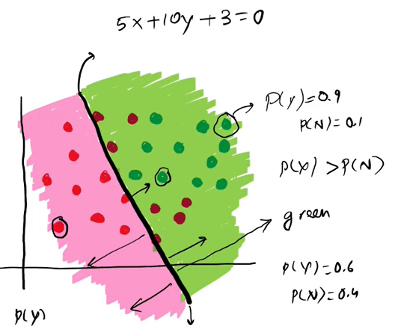

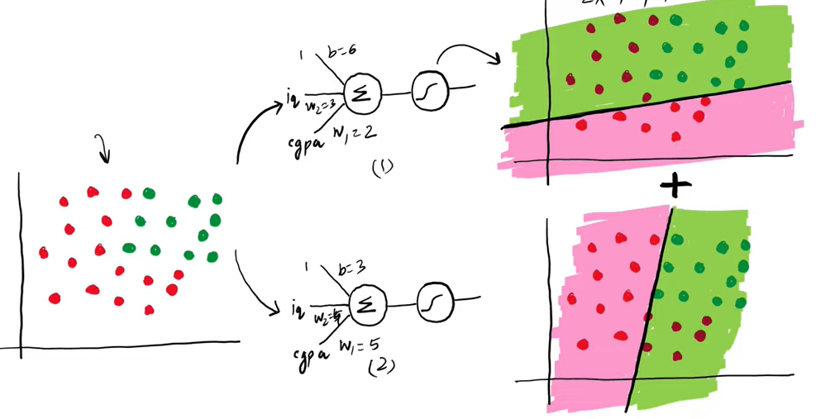

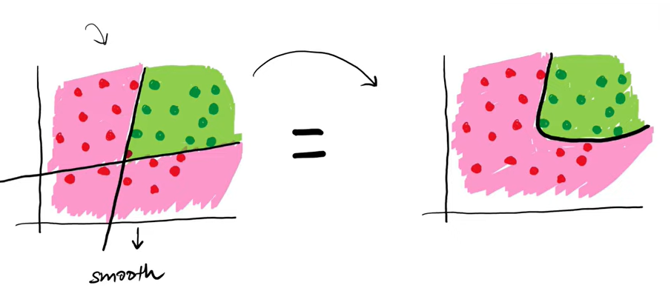

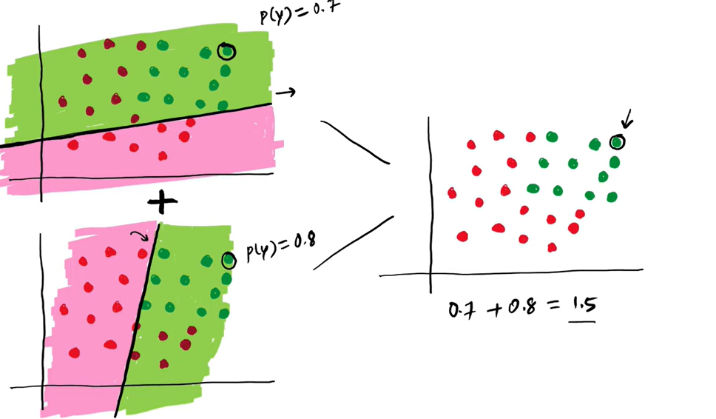

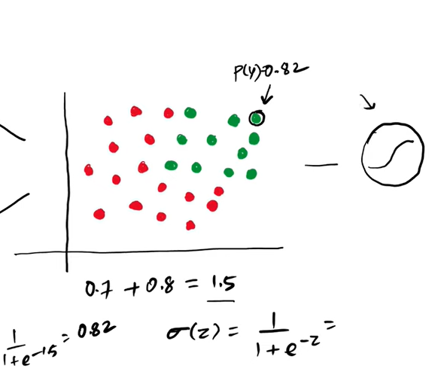

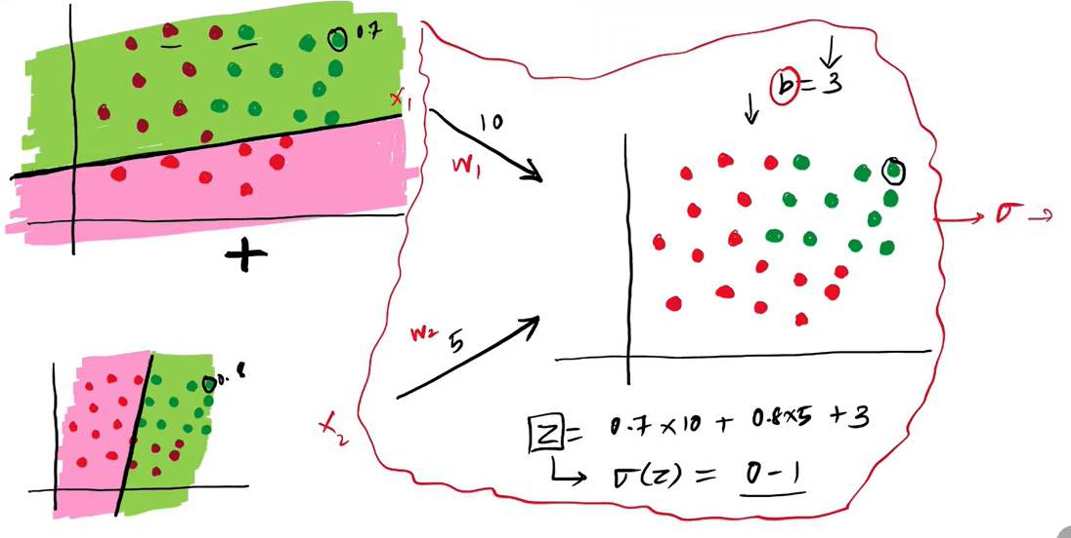

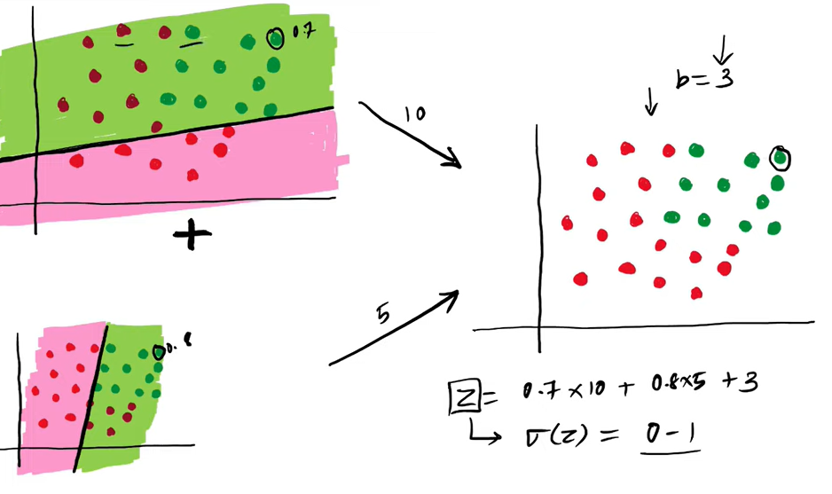

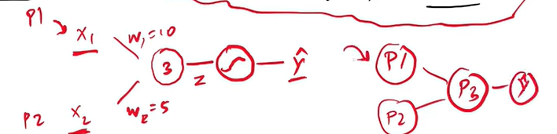

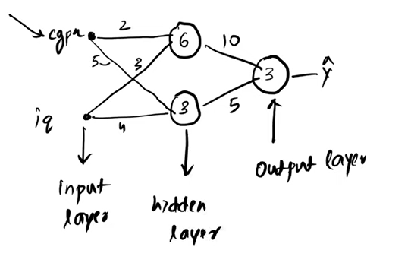

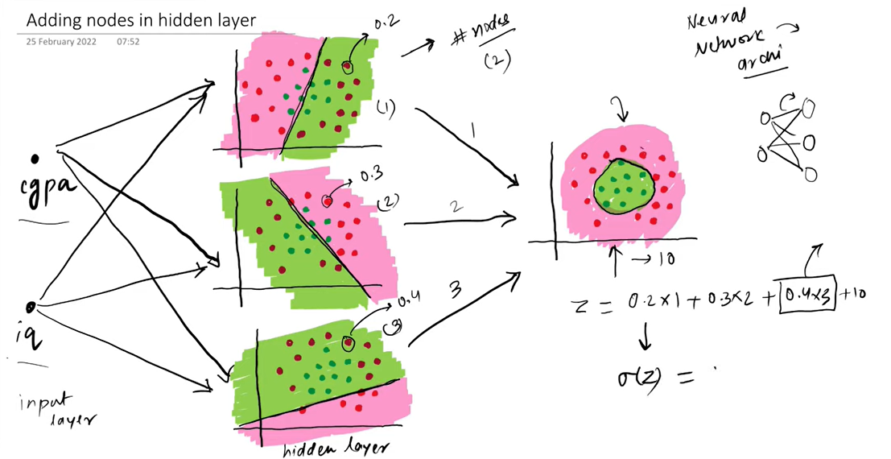

Helps with more complex non-linear data

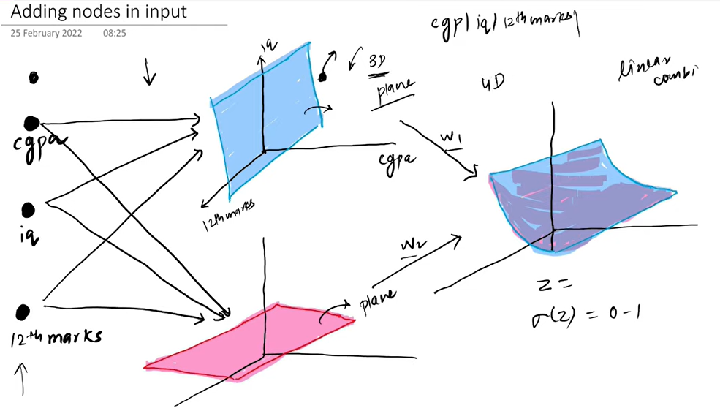

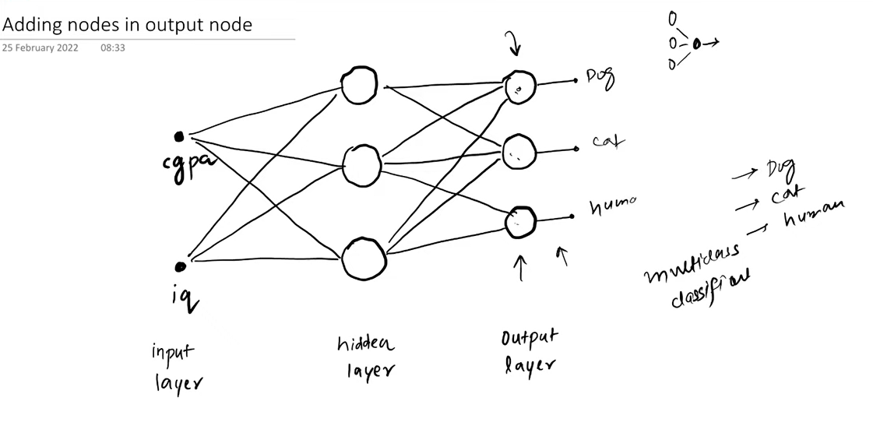

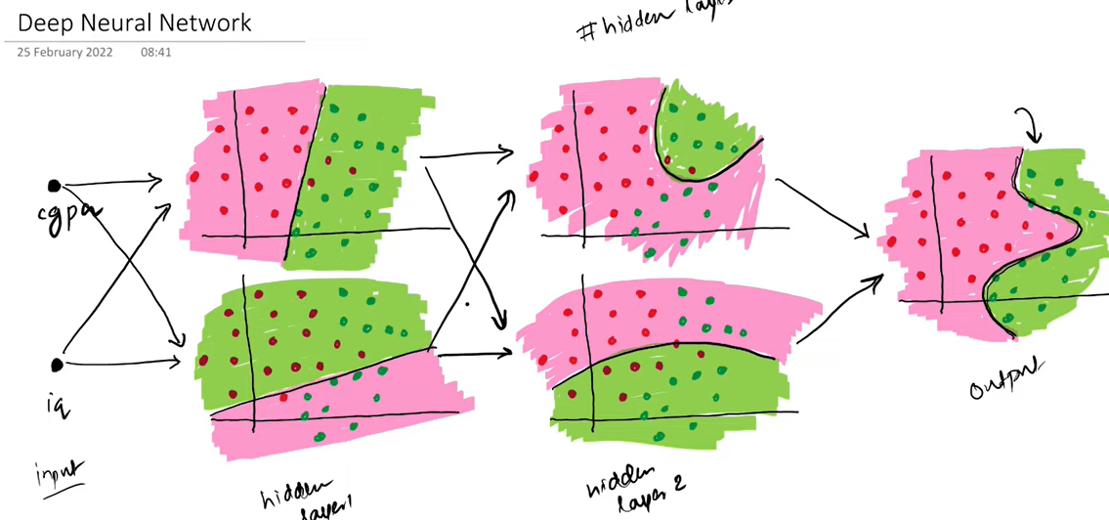

Questions

1. What is deep learning?
A. A rule-based AI system
B. Machine learning using shallow models
C. Machine learning using neural networks with multiple hidden layers
D. A statistical data analysis technique

2. What is a perceptron?
A. A deep neural network
B. A single-layer neural network used for binary classification
C. A clustering algorithm
D. A reinforcement learning model

4. What does the bias term in a perceptron do?
A. Prevents overfitting
B. Adjusts the learning rate
C. Shifts the decision boundary
D. Normalizes the input
✅

5. Which activation function is commonly used in perceptrons?
A. ReLU
B. Sigmoid
C. Step function
D. Softmax

6. What makes deep learning “deep”?
A. Large datasets
B. High learning rate
C. Multiple hidden layers
D. Complex loss functions

7. What is a Multi-Layer Perceptron (MLP)?
A. A perceptron without bias
B. A neural network with one or more hidden layers
C. A CNN for image processing
D. A recurrent neural network

8. Which algorithm is used to train MLPs?
A. K-means
B. Apriori
C. Backpropagation
D. PCA

9. Why can MLPs solve non-linear problems?
A. They use large datasets
B. They use multiple hidden layers
C. They use unsupervised learning
D. They use reinforcement learning
✅ Answer: B

10. Which activation function is commonly used in hidden layers of deep networks?
A. Step
B. Linear
C. ReLU
D. Binary

